25/08/2023

**PROGRAM1: To find given number is even or odd**

**Code:**

#include<stdio.h>

int main()

{

int n;

printf("Enter the number: ");

scanf("%d",&n);

if(n%2==0)

printf("The number is even.");

else

printf("The number is odd.");

}

**Sample input and Output:**

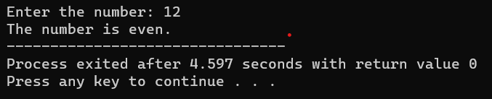

**PROGRAM2: To find sum of first n numbers using any loop**

**Code:**

#include <stdio.h>

int main()

{

int i, n, sum=0;

printf("Enter the limit: ");

scanf("%d", &n);

for(i=1; i<=n; i++)

{

sum = sum + i;

}

printf("Sum of first %d natural numbers = %d", n, sum);

}

**Sample input and Output:**

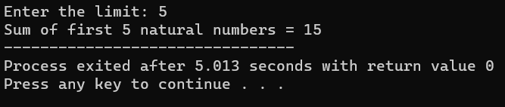

**PROGRAM3: To find sum of first n even numbers**

**Code:**

#include<stdio.h>

int main()

{

int n, i, sum = 0 ;

printf("Enter a Number: ");

scanf("%d",&n);

for(i=1;i<=n;i++)

{

if(i%2==0)

{

sum = sum + i;

}

}

printf("\nSum of first %d even Numbers: %d",n,sum);

}

**Sample input and Output:**

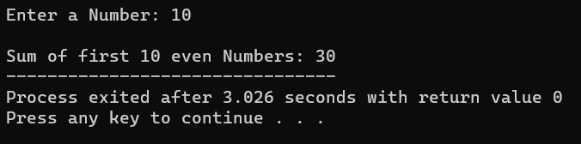

**PROGRAM4: To find sum of first n odd numbers**

**Code:**

#include<stdio.h>

int main()

{

int n, i, sum = 0 ;

printf("Enter a Number: ");

scanf("%d",&n);

for(i=1;i<=n;i++)

{

if(i%2!=0)

{

sum = sum + i;

}

}

printf("\nSum of first %d even Numbers: %d",n,sum);

}

**Sample input and Output:**

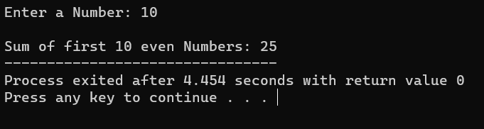

**PROGRAM5: To find factorial of given number with recursion**

**Code:**

#include<stdio.h>

int multiplyNumbers(int n);

int main() {

int n;

printf("Enter a number: ");

scanf("%d",&n);

printf("Factorial of %d = %ld", n, multiplyNumbers(n));

return 0;

}

int multiplyNumbers(int n) {

if (n>=1)

return n*multiplyNumbers(n-1);

else

return 1;

}

**Sample input and Output:**

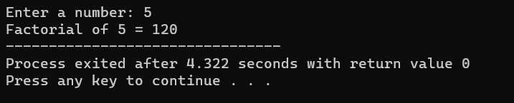

**PROGRAM6: To find factorial of given number**

**Code:**

#include <stdio.h>

int main() {

int n, i;

int fact = 1;

printf("Enter a number: ");

scanf("%d", &n);

if (n < 0)

printf("Error! Factorial of a negative number doesn't exist.");

else {

for (i = 1; i <= n; ++i) {

fact = fact*i;

}

printf("Factorial of %d = %d", n, fact);

}

}

**Sample input and Output:**

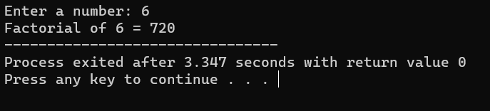

**PROGRAM7: To find fibonacci series with recursion**

**Code:**

#include <stdio.h>

int fib(int a, int b, int sum, int N)

{

if (N != 0) {

printf(" %d", a);

sum = a + b;

a = b;

b = sum;

N--;

fib(a, b, sum, N);

}

}

int main()

{

int n;

printf("Enter till what number: ");

scanf("%d",&n);

fib(0, 1, 0, n);

return 0;

}

**Sample input and Output:**

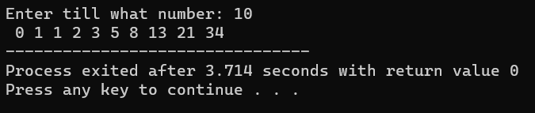

**PROGRAM8: To find fibonacci series**

**Code:**

#include <stdio.h>

int main() {

int t1 = 0, t2 = 1, nextTerm = 0, n;

printf("Enter a number: ");

scanf("%d", &n);

printf("Fibonacci Series: %d, %d, ", t1, t2);

nextTerm = t1 + t2;

while (nextTerm <= n) {

printf("%d, ", nextTerm);

t1 = t2;

t2 = nextTerm;

nextTerm = t1 + t2;

}

return 0;

}

**Sample input and Output:**

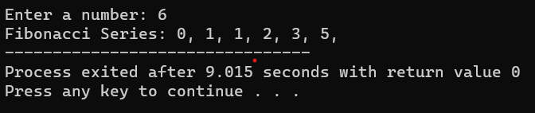

**PROGRAM9: To reverse a given number**

**Code:**

#include <stdio.h>

int main() {

int n, rev = 0, rem;

printf("Enter a number: ");

scanf("%d", &n);

while (n != 0) {

rem = n % 10;

rev = rev * 10 + rem;

n =n/10;

}

printf("Reversed number = %d", rev);

return 0;

}

**Sample input and Output:**

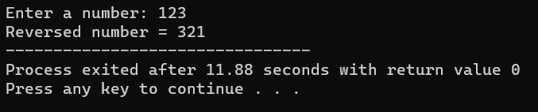

**PROGRAM10: To check whether number is palindrome or not**

**Code:**

#include <stdio.h>

int main() {

int n, rev = 0, rem, ori;

printf("Enter a number: ");

scanf("%d", &n);

ori = n;

while (n != 0) {

rem = n % 10;

rev = rev * 10 + rem;

n /= 10;

}

if (ori == rev)

printf("%d is a palindrome.", ori);

else

printf("%d is not a palindrome.", ori);

return 0;

}

**Sample input and Output:**

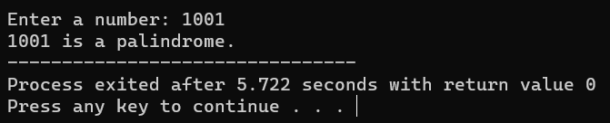

**PROGRAM11: To check whether number is armstrong or not**

**Code:**

#include <stdio.h>

int main() {

int n, ori, rem, result = 0;

printf("Enter a three-digit number: ");

scanf("%d", &n);

ori = n;

while (ori != 0) {

rem = ori % 10;

result += rem * rem * rem;

ori /= 10;

}

if (result == n)

printf("%d is an Armstrong number.", n);

else

printf("%d is not an Armstrong number.", n);

return 0;

}

**Sample input and Output:**

